

|  |  |
| --- | --- |
|  | Lab 8 |
|  |  |
|  | Akshar panchani- ID 202101522  CT303 Digital Communication  11/19/23 |

**Experiment 1:**

Input Data Type: 8-bit and 32-bit

CH1: Input Data (TP10) CH1: Input Data (TP10)

CH2: Carrier Signal (TP11) CH2: BPSK out (TP12)

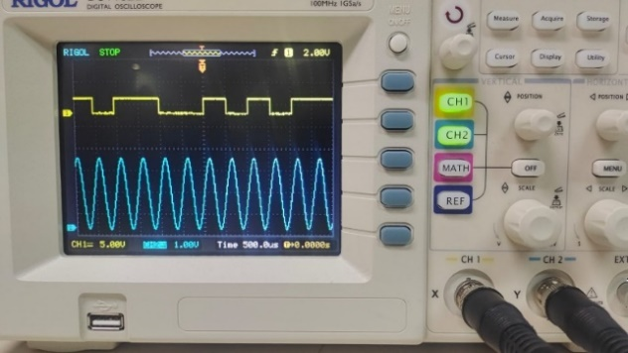 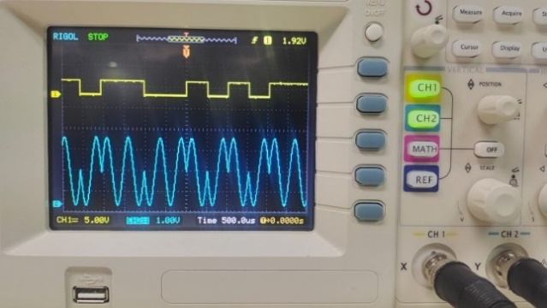

CH1: Carrier Signal (TP11) CH1: Input Data (TP10)

CH2: BPSK out (TP12) CH2: BPSK out (TP12)

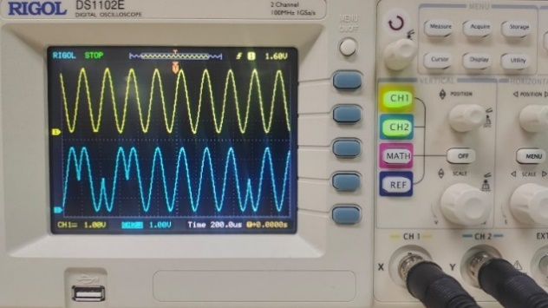 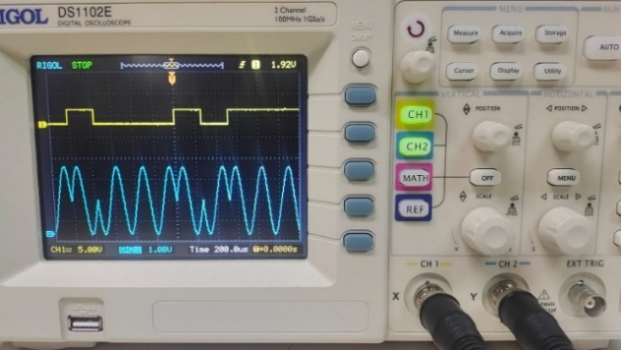

CH1: BPSK out (TP12) CH1: BPSK out (TP12)

CH2: Multiplier out (TP14) CH2: Multiplier out (TP14)

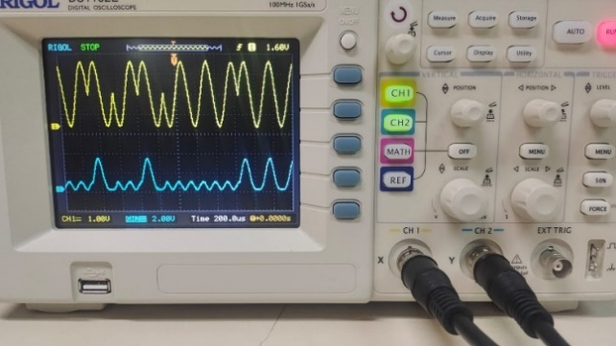 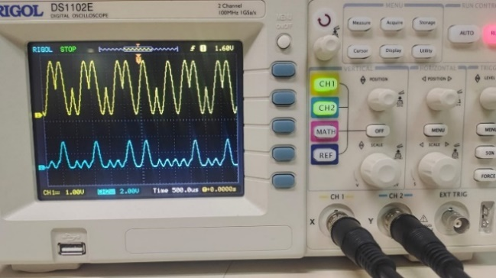

CH1: BPSK (TP12)

CH2:Integrator out (TP15)

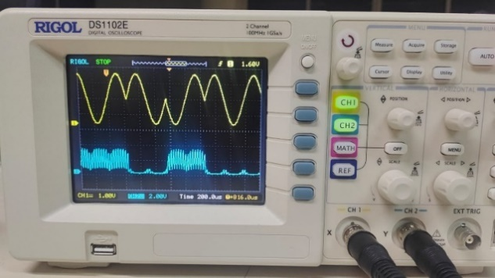

CH1: BPSK out (TP12) CH1: Encoded input Data (TP10)

CH2: Comparator Out (TP16) CH2: Comparator out (TP16)

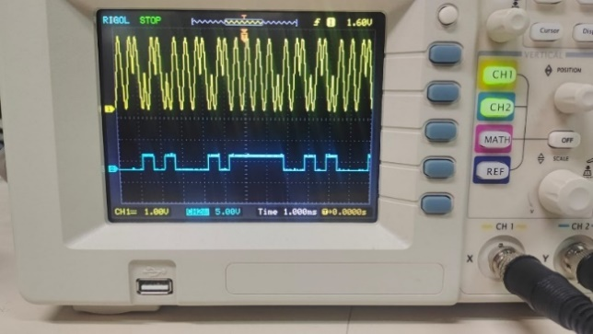 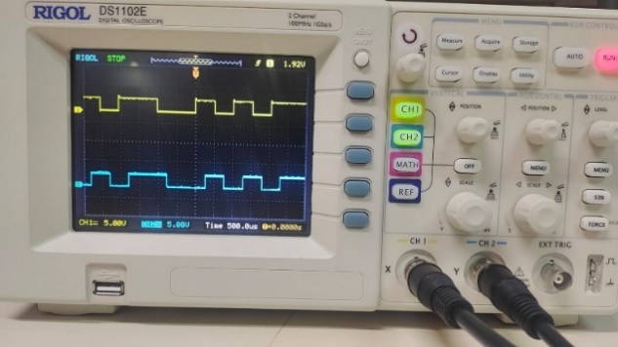

CH1: BPSK out (TP12)

CH2: Integrator Out (TP15)

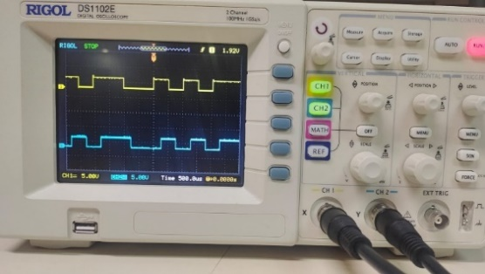

**Experiment 2:**

Input Data Type: 8-bit

Data clock Freq: 2KHz

CH1: Input Data (TP2) CH1: Carrier Signal F1 (TP30)

CH2: Encoded Input Data (TP28) CH2: Carrier Signal F2 (TP29)

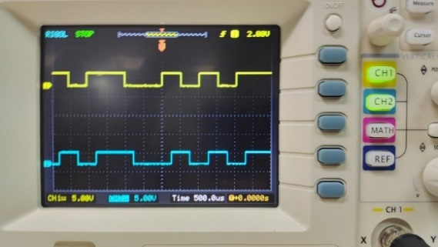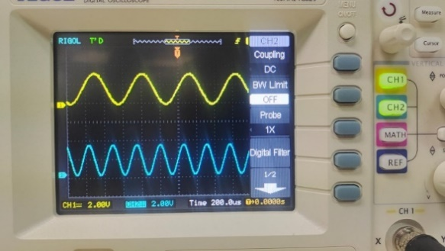

CH1: Encoded Input Data (TP28)

CH2: FSK Output (TP28)

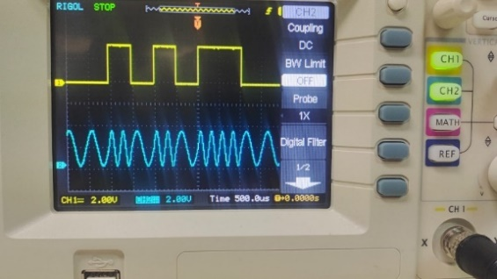

CH1: FSK output (TP31) CH1: FSH output (TP31)

CH2:Multiplier Out (TP34) CH2: Multiplier out (TP35)

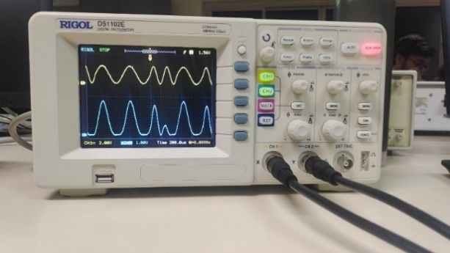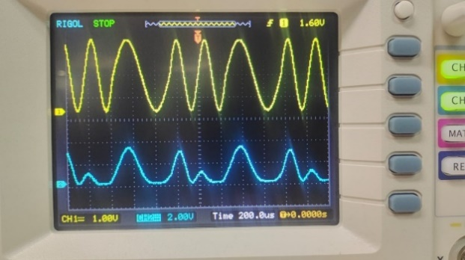

CH1: FSK output (TP31) CH1: FSK Output (TP31)

CH2: Integrator Out (TP36) CH2: Integrator out (TP37)

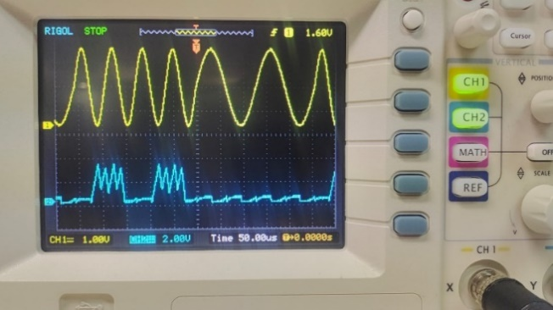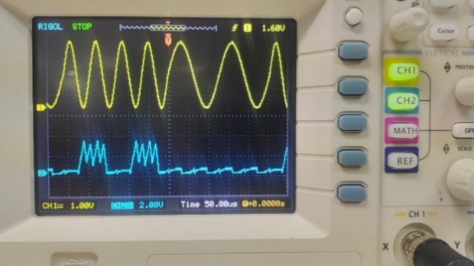

CH1: FSK Output (TP31) CH1: Input Data (TP28)

CH2: Sigma Out (TP38) CH2: Comparator out (TP39)

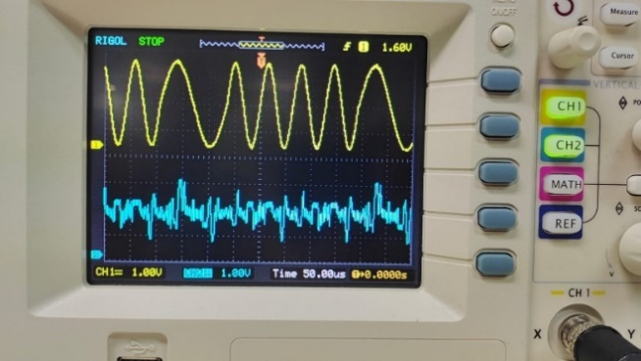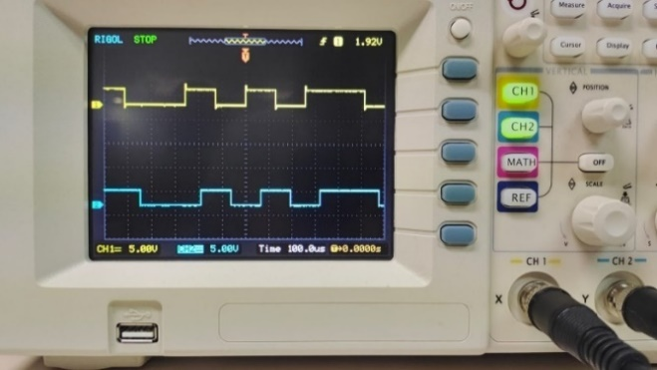

CH1: Input Data (TP28) CH1: Input Data (TP28)

CH2: Demodulator out (TP39) CH2: Demodulator out (TP39)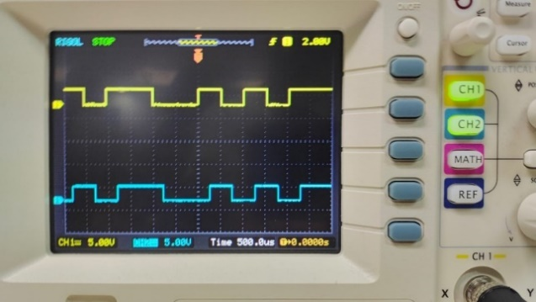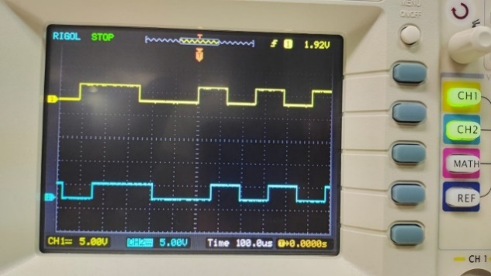

**Experiment: 3:**

n = 10^6;

x = rand(1, n);

m = 100;

y = mean(reshape(x, m, []));

bins = 50;

hist(y, bins);

title('Histogram of y');

xlabel('Value of y');

ylabel('Frequency');

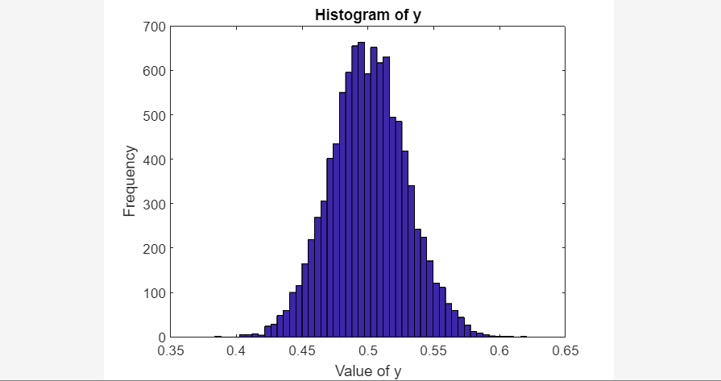

It is evident that the histogram approximately follows a Gaussian distribution and resembles a bell-shaped curve. Consequently, the central limit theorem supports it.